**Res.html**

<html>

<head>

<title>

Online resume

</title>

<meta charset="UTF-8"/>

<link rel="stylesheet" href=res.css>

</head>

<body>

<center>

<img class="circle" src="pic.jpg"></img>

<b><p class="p">Nayan Dharviya</p></b>

<p><center><b>

<a span id="c1" href="RESUMEFINAL.html">Resume</span></a>

<a span id="c2" href="contact.html">Contact No.</span></a>

<a span id="c3" href="email.html">G-mail</span></a>

</center>

</b></p>

</center>

</body>

</html>

**Output**

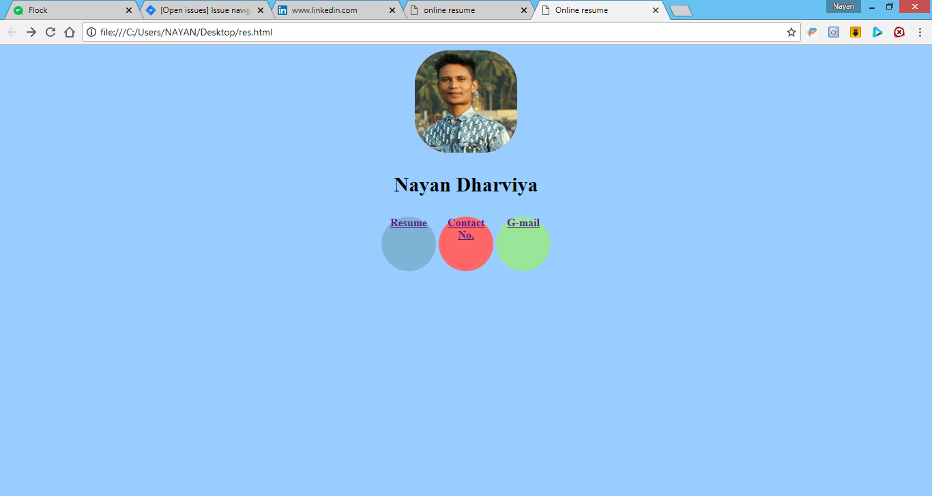

**RESUMEFINAL.html**

<html>

<head>

<title>

Online resume

</title>

<meta charset="UTF-8"/>

<link rel="stylesheet" href=res.css>

</head>

<body>

<center>

<h1>CURRICULAM VITAE</H1>

<hr noshade size=2 color=black>

</center>

<b><h3>

NAYAN GOPAL DHARVIYA

<h3></b>

<h4>

001, I-wing, Jai Gurudev Complex, <br>

Kalher, Bhiwandi - 421302<br>

Email : nayandharviya123@gmail.com <br>

Mob : 09890488137</h4>

<b><h3>

<u>CARRER OBJECTIVE

</u></b></h3>

<hr noshade size=2 color=black>

To work in a challenging environment demanding all my skills and adapt myself in different fields for the development of the

organisation with impressive performance.

<b><h3>EDUCATION QUALIFICATION</b></h3>

<hr noshade size=2 color=black>

<table border="2">

<theader>

<th>Examination</th>

<th>Institution</th>

<th>Board/ University</th>

<th>Year Of Passing </th>

<th>Percentage</th>

</theader>

<tfooter>

<tr>

<td>T.Y. B.Sc.IT</td>

<td>N.K.T.T., Thane</td>

<td>University Of Mumbai</td>

<td>2017</td>

<td> 73.74%</td>

</tr>

<tr>

<td>S.Y.B.Sc.IT </td>

<td>N.K.T.T., Thane </td>

<td>University Of Mumbai</td>

<td>2017 </td>

<td>81.86 %</td>

</tr>

<tr>

<td>F.Y.B.Sc.IT</td>

<td>N.K.T.T., Thane </td>

<td>University Of Mumbai</td>

<td>2016 </td>

<td>76.06 %</td>

</tr>

<tr>

<td>HSC</td>

<td>SK Somaiya</td>

<td>Maharashtra State Board </td>

<td>2015 </td>

<td>57.84 %</td>

</tr>

<tr>

<td>SSC </td>

<td>S.H.V.O.V.</td>

<td>Maharashtra State Board</td>

<td>2013 </td>

<td>80.72 %</td>

</tr></tfooter>

</table>

<b><h3>

TECHNICAL SKILLS</b>

</h3>

<hr noshade size=2 color=black>

<ul>

<li>Programming Language: C++ , Java </li>

<li>Operating Systems : Windows , Linux</li>

<li>Web Technology : HTML ,CSS , Asp.net</li>

<li>Database : SQL Server 2008 </li>

</ul>

<b><h3>

AREA OF INTREST</b>

</h3>

<hr noshade size=2 color=black>

<ul>

<li>C++, DBMS(SQL,PL/SQL), JAVA,NETWORKING</li>

</ul>

<b><h3>

ACHIVMENTS</b>

</h3>

<hr noshade size=2 color=black>

<ul>

<li>Participated in NSS and did many Social work, and complete Seven days camp.</li>

<li>Got Certificates in Sports in school.</li>

<li>Got Certificate of being topper of S.Y.B.Sc.IT class.</li>

</ul>

<b><h3>

STRENGTH</b>

</h3>

<hr noshade size=2 color=black>

<ul>

<li>Sincere, Self-confident and Hard as well as smart Working.</li>

<li>Keep interest and ability to learn new technology.</li>

<li>Ability to do a work with team.</li>

</ul>

<b><h3>

FINAL YEAR PROJECT</b>

</h3>

<hr noshade size=2 color=black>

<ul>

<li>Title &nbsp;&nbsp;&nbsp;&nbsp;&nbsp; : GST Billing System</li>

<li>Environment:<br>

&nbsp;&nbsp;&nbsp;&nbsp;&nbsp;

Front-End : Visual C#<br>

&nbsp;&nbsp;&nbsp;&nbsp;&nbsp; Back-End : SQL Server 2008<br>

&nbsp;&nbsp;&nbsp;&nbsp; Team Size : 2<br>

&nbsp;&nbsp;&nbsp;&nbsp;&nbsp; Duration &nbsp; : 6 months<br>

&nbsp;&nbsp;&nbsp;&nbsp;&nbsp; Role &nbsp;&nbsp;&nbsp; &nbsp;&nbsp;&nbsp; : Designer, Developer,

Tester<br>

&nbsp;&nbsp;&nbsp;&nbsp;&nbsp;

Description : GST Billing System is a desktop application. This System provides the Details of all Customers,

Suppliers and Products. And also generates the Reports like Bill report, item wise sale/purchase report, Customer sale Report

(date/month/year) wise. And it also allow the user to find GST Amount (month/year/day) wise .<br>

&nbsp;&nbsp;&nbsp;&nbsp;&nbsp;

Objective : 1. To reduce the paper work.<br> &nbsp;&nbsp;&nbsp;&nbsp;&nbsp;&nbsp;

&nbsp;&nbsp;&nbsp;&nbsp;&nbsp;&nbsp; &nbsp;&nbsp;&nbsp;&nbsp;&nbsp; &nbsp;&nbsp;&nbsp;

2. To reduce the manual work.<br>

&nbsp;&nbsp;&nbsp;&nbsp;&nbsp;&nbsp; &nbsp;&nbsp;&nbsp;&nbsp;&nbsp;&nbsp;

&nbsp;&nbsp;&nbsp;&nbsp;&nbsp;&nbsp; &nbsp;&nbsp;

3. To improve and easily maintain the business. <br>

&nbsp;&nbsp;&nbsp;&nbsp;&nbsp;&nbsp; &nbsp;&nbsp;&nbsp;&nbsp;&nbsp;&nbsp;

&nbsp;&nbsp;&nbsp;&nbsp;&nbsp;&nbsp; &nbsp;&nbsp;

4. Accurate result can be obtained.<br>

</ul>

<b><h3>PERSONAL PROFILE</b>

</h3>

<hr noshade size=2 color=black>

<ul>

<li>

Date of Birth : 23rd January, 1998</li>

<li>

Gender : Male</li>

<li>

Marital Status : Single</li>

<li>

Nationality : Indian</li>

<li>

Hobbies : Playing Cricket, Bad-Minton, and Chess and Listening Music.</li>

Language Known : English, Marathi, Hindi and Gujarati

</ul>

<b><h3>DECLARATION</b>

</h3>

<hr noshade size=2 color=black>

<p >I hereby affirm that the information in this document is accurate and true to the best of my knowledge.</p>

</body>

</html>

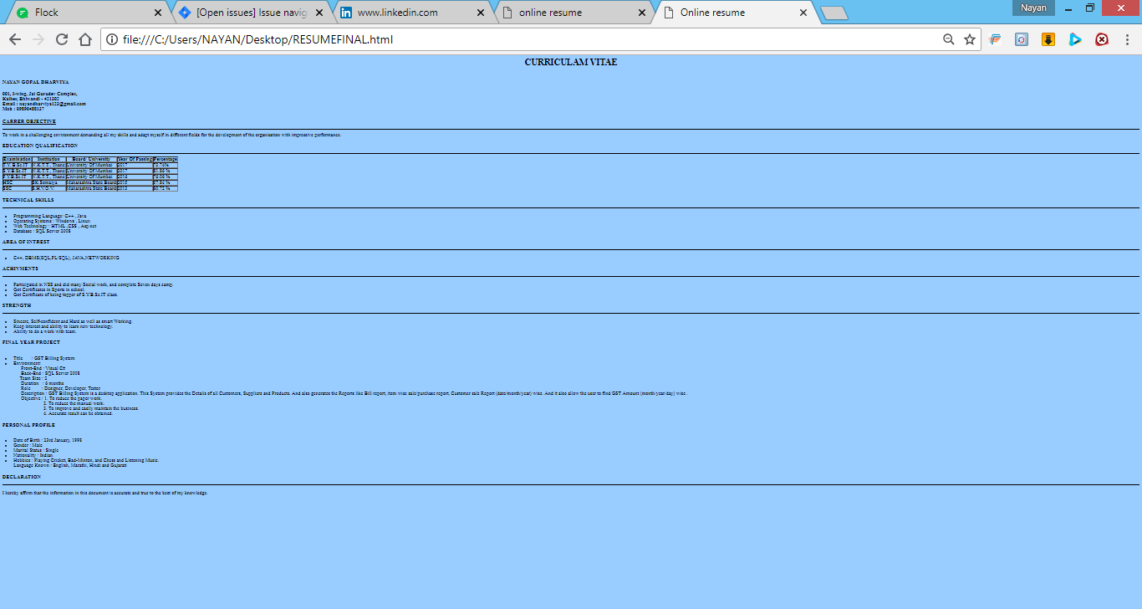

**Contact.html**

<html>

<head>

<title>

Online resume

</title>

<meta charset="UTF-8"/>

<link rel="stylesheet" href=res.css>

</head>

<body>

<center>

<h1 class="co">9890488137</h1>

<h1 class="co1">9766288755</h1>

</center>

</body>

</html>

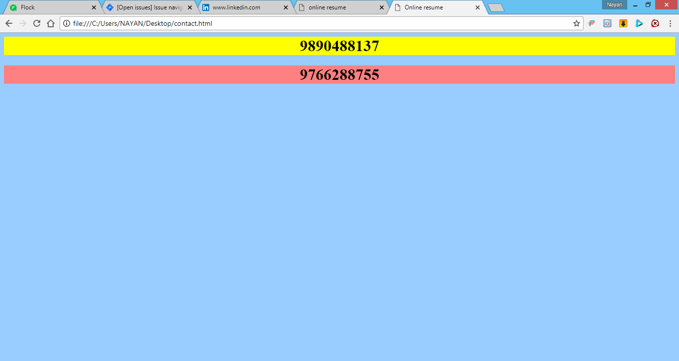

**Email.html**

<html>

<head>

<title>

Online resume

</title>

<meta charset="UTF-8"/>

<link rel="stylesheet" href=res.css>

</head>

<body>

<center>

<h1

class="co">nayandharviya123@gmail.com</h1>

<h1

class="co1">nayandharviya55@gmail.com</h1>

</body>

</html>

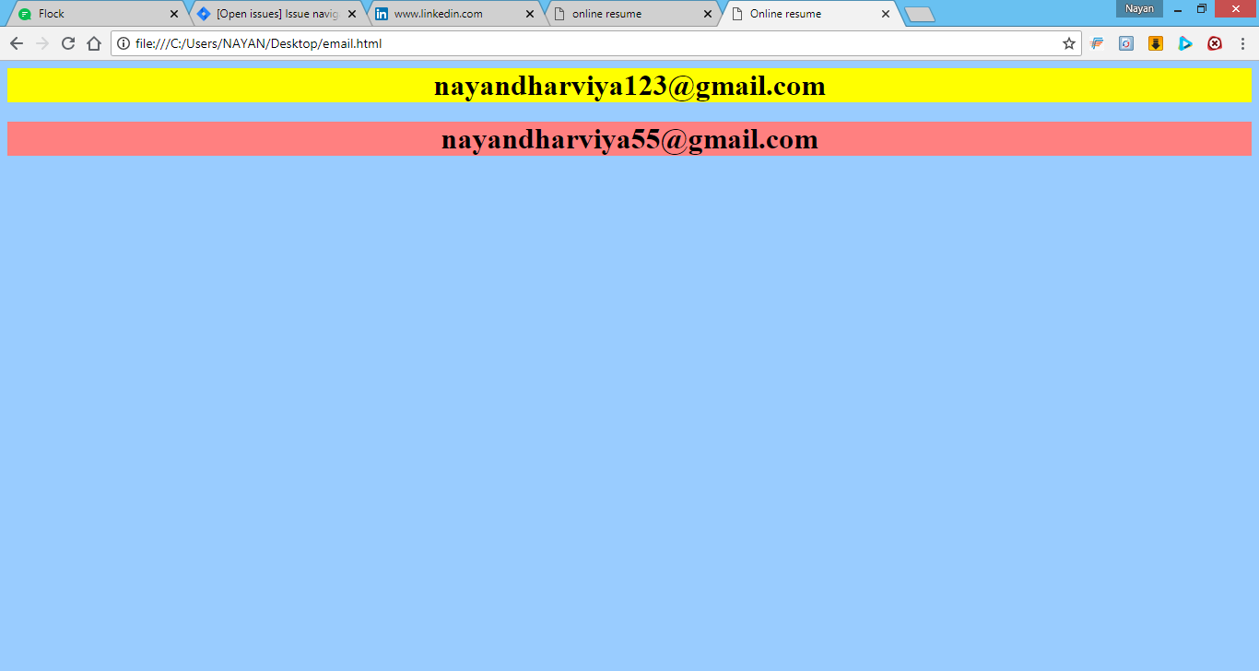

**Res.css**

.circle

{

height:150px;

width:150px;

border-radius:50px;

background-color:red;

display:inline-block;

}

body

{

background-color:99ccff;

}

.p

{

font-family:"Times New

Roman",Helvetica,sans-serif;

font-size:30px;

}

#c1

{

display:table-cell;

height:80px;

width:80px;

border-radius:50%;

background-color:#7FB3D5;

display:inline-block;

text-align:center;

vertical-align:middle;

}

#c2

{vertical-align:middle;

height:80px;

width:80px;

border-radius:50%;

background-color:#ff6666;

display:inline-block;

text-align:center;

}

#c3

{vertical-align:middle;

height:80px;

width:80px;

border-radius:50%;

background-color:#99e699;

display:inline-block;

text-align:Center;

}

.co

{

background-color:yellow;

}

.co1

{

background-color:ff8080;

}

.l

{

border-right:5px;

height:1000px;

}

.b

{

color:black;

}

.table

{

border="1";

}